**Measuring properties of labeled or segmented regions using Python :**

**(1) Read our image and convert it into rgb2gray :**

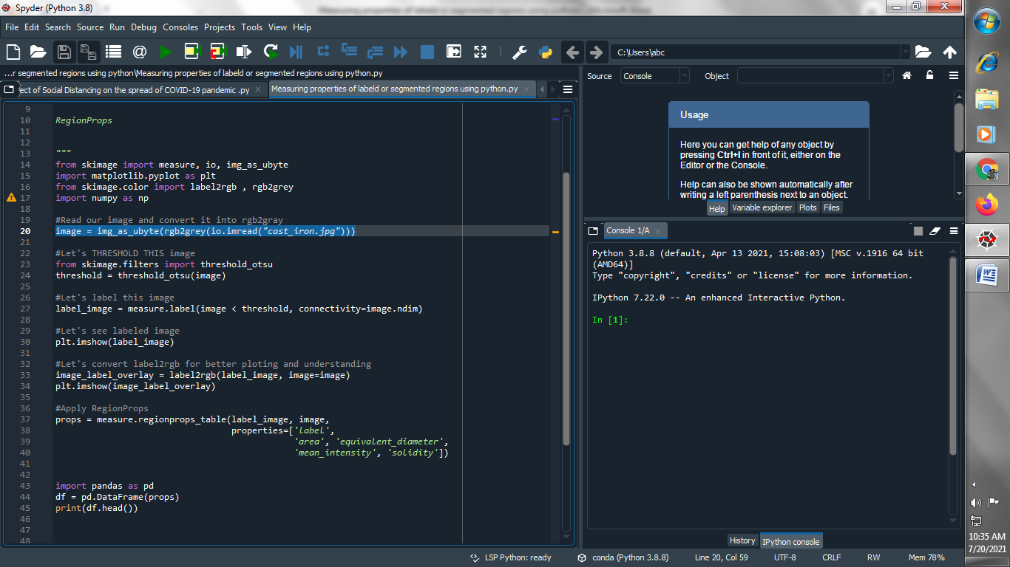

**(2) Let's THRESHOLD THIS image :**

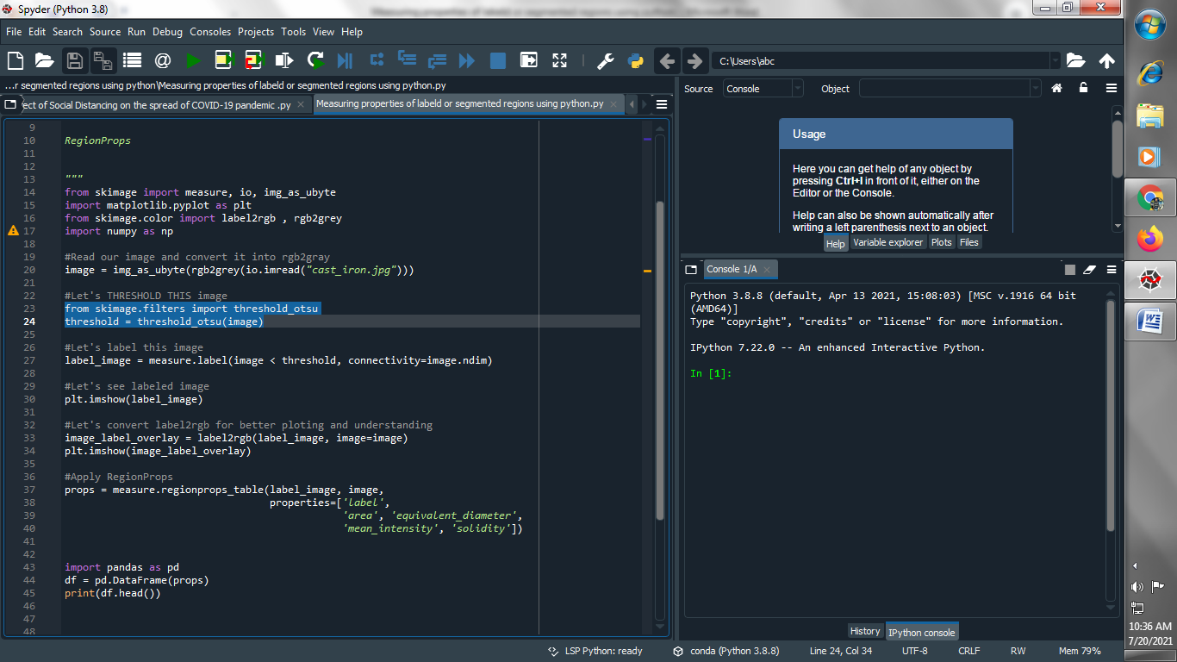

**(3) Let's label this image :**

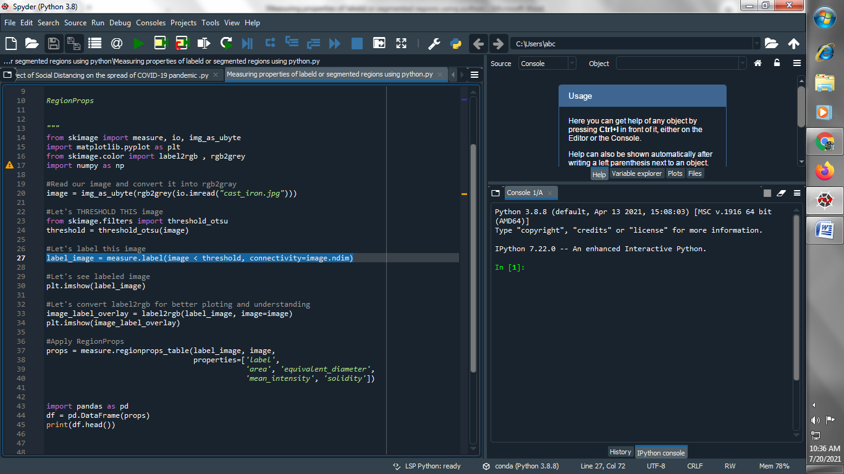

**(4) Let's see labeled image :**

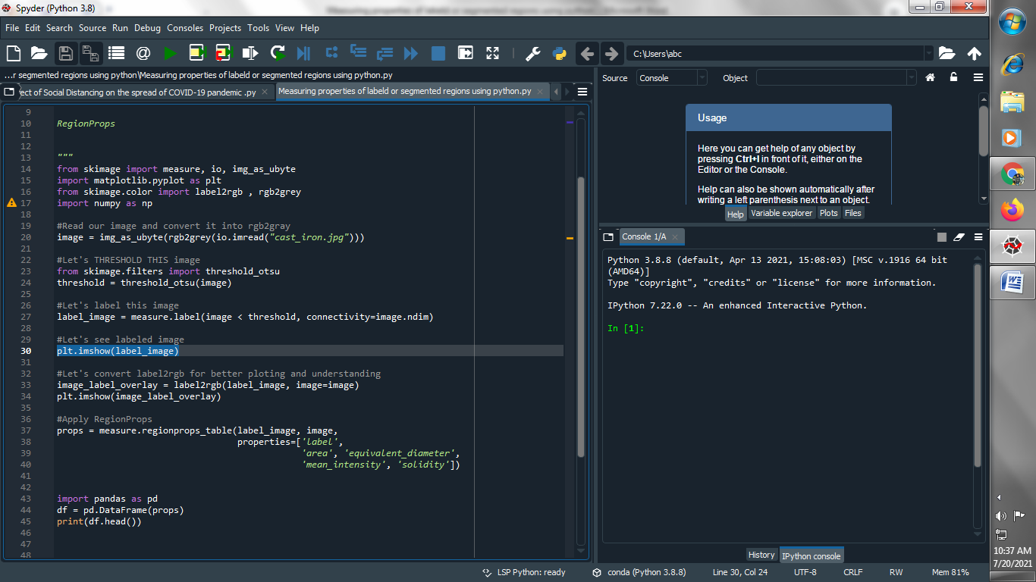

**Output :**

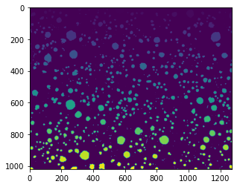

**(5) Let's convert label2rgb for better ploting and understanding :**

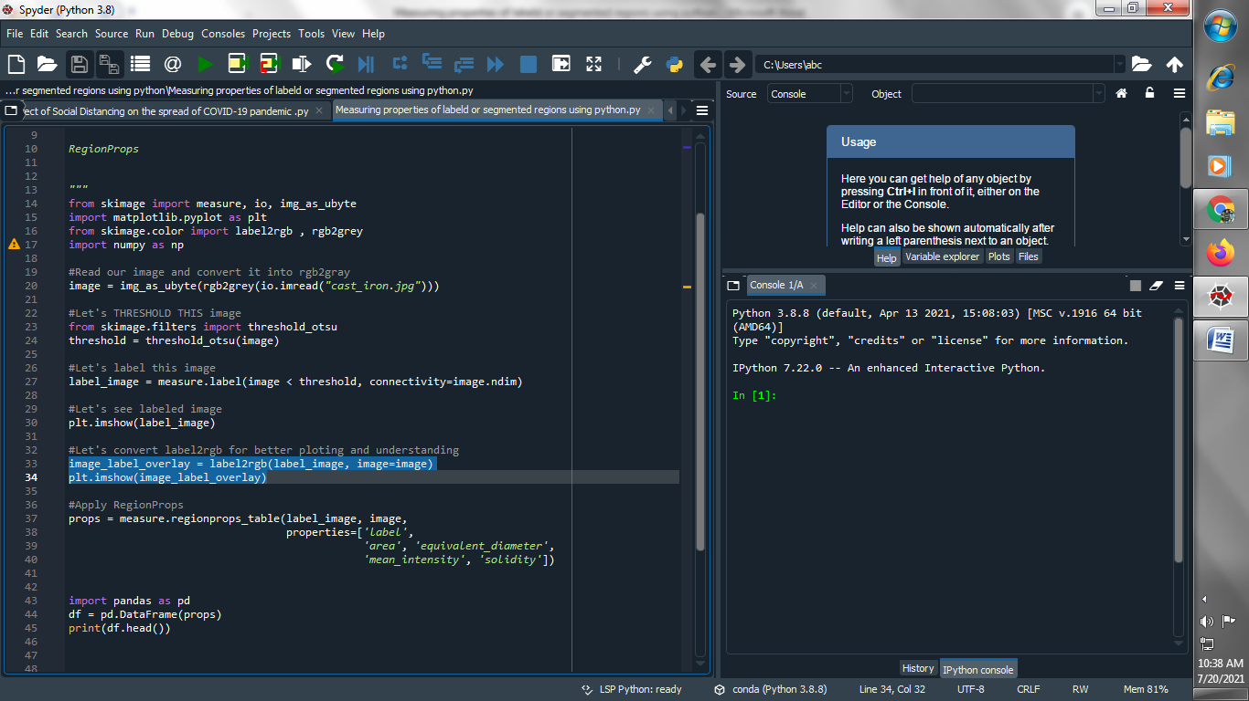

**Output :**

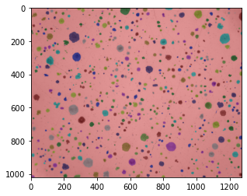

**(6) Apply RegionProps :**

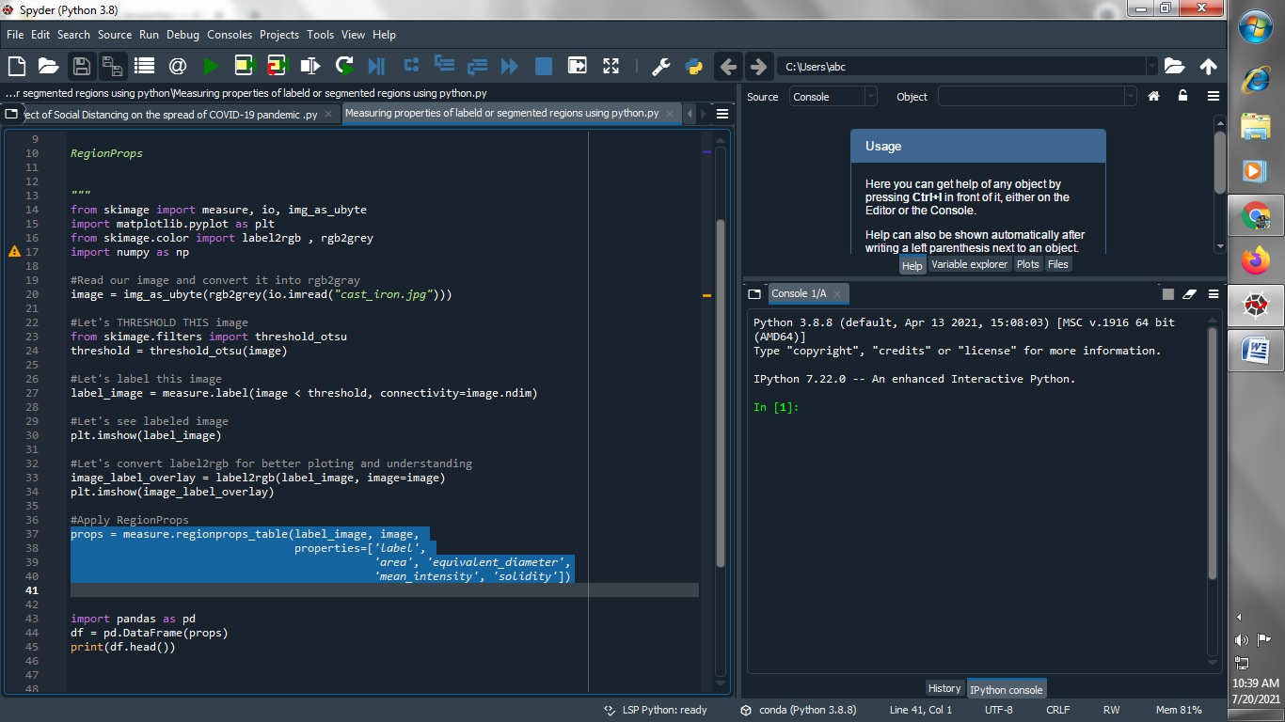

**(7) Let's see props dataframe :**

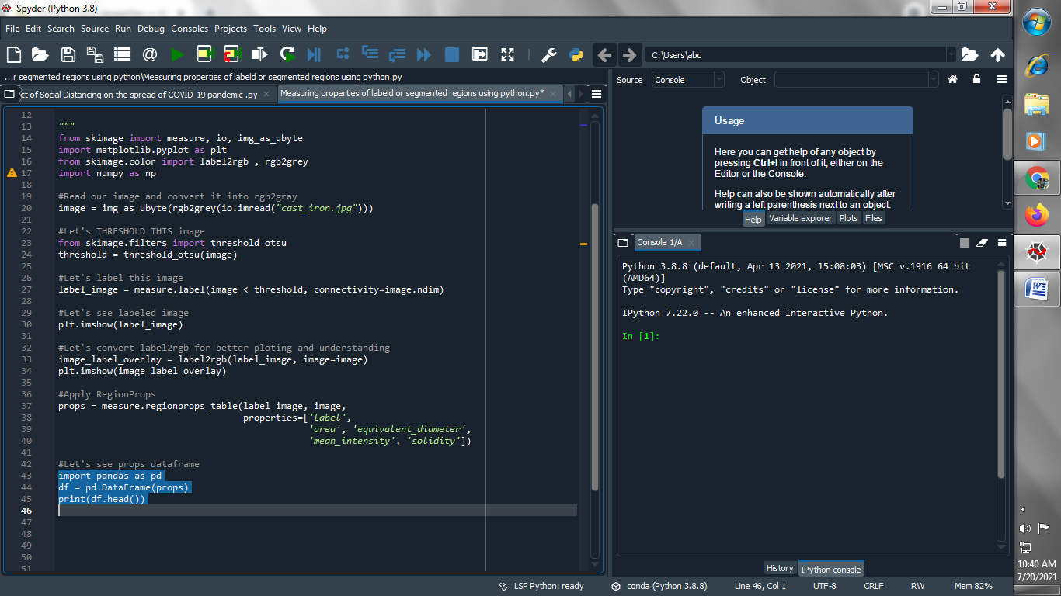

**Output :**

